**Introduction**

Condominium buyers tend to have preferences about a unit’s location within a complex. Some buyers prefer lower floors because of the less time spent in elevators and easier evacuation in case of emergencies. While others prefer the grander view available from the higher floors. Often higher floors can offer more privacy and less traffic as these floors are further away from the parking lot. Another location factor that can affect the price of a unit is whether the unit is located on a corner of the building. Corner units will usually have more natural light, larger balconies, and lower level of noise because of only having neighbors on one side. However, corner units tend to have higher electricity bills and they tend to be farthest away from the elevators. Which may be a positive or negative feature depending on the buyer [1].

This analysis investigates the relationship between condominium sale price, and the independent variables height of the unit (floor number), distance of the unit from the elevator, presence, or absence of an ocean view and whether the unit is an end unit from a seller’s perspective. This is accomplished by finding a statistical model that best describes the observed data and utilize this model to investigate how the seller’s fixed price is influenced by the independent variables.

**Data & Methods**

The sales data was obtained from a new oceanside condominium complex consisting of two adjacent and connected eight-floor buildings. The complex contains 209 units of equal size (approximately 500 square feet each). There are several features of the complex that should be noted. The units facing south, called *oceanview*, face the beach and ocean. Units with an ocean view ending with number 11 have their view partially blocked by building 2. In addition, units in building 1 have a good view of the pool. Units to the rear of the building, called *bayview*, face the parking lot and an area of land that ultimately borders a bay. The view from the upper floors of these units is primarily of wooded, sandy terrain. The bay is very distant and barely visible. The only elevator in the complex is located at the east end of building 1, as are the office and the game room.

The condominium complex was completed during a recession; sales were slow, and the developer was forced to sell most of the units at auction approximately 18 months after opening. Many unsold units were furnished by the developer and rented prior to the auction. The data is divided into units that were sold at a fixed price by the owner (103 units) and others that were sold at auction (106 units). Further, the data contains information about the sales price, floor height (level), distance from the elevator (measured along the length of the complex and expressed in number of condominium units), view of the ocean, end unit (unit numbers ending in 11), and furniture. This analysis will focus on the units sold at a fixed price by the owner.

The data was imported into JMP and filtered to keep only units that were sold at a fixed price. This subset data set was used for the analysis.

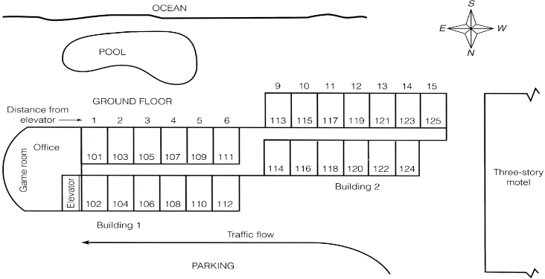

Figure 1 A map depicting the layout of the condominium complex

|  |  |  |
| --- | --- | --- |
| Y | | Condominium sale price (in 100$) |
| X1 | | Floor height |
| X2 | | Distance from the elevator |
| X3 | 1 | If an ocean view |
|  | 0 | If not |
| X4 | 1 | If an end unit |
|  | 0 | If not |

Table 1 Variable descriptions

Model 1, the simplest model to be considered. Model 1 assumes the five factors affect the price in an independent manner and that the effect of the two quantitative factors on sale price is linear.

Model 1: E(y) = B0 + B1X1 + B2X2 + B3X3+ B4X4

Model 2, a first order model like model 1, however, model 2 considers interaction between the quantitative variables (floor level and distance) and the qualitative variables (ocean view, end unit).

Model 2: E(y) = B0 + B1X1 + B2X2 + B3X3 + B4X4 + B5X1X3 + B6X1X4 + B7X2X3 + B8X2X4 + B9X3X4

Model 3, a second order model with interactions between the quadratic terms of floor level, distance from the elevator and the qualitative variables ocean view, end unit.

Model 3: E(y) = B0 + B1X1 + B2X2 + B3X3 + B4X4 + B5X1X3 + B6X1X4 + B7X2X3 + B8X2X4 + B9X3X4 B10X1X1 + B11X2X2 + B12X1X2 + B13X1X1X3 + B14X1X1X4 + B15X2X2X3 + B16X2X2X4

Model 4, a second order interaction model same as model 3 except this model considers quadratic interaction terms between the two quantitative variables (floor level and distance from elevator) and the qualitative variables (end unit and ocean view). Plus, model 4 considers the quadratic interaction term between the interaction of the quantitative variables and the interaction of the qualitative variables.

Model 4: E(y) = B0 + B1X1 + B2X2 + B3X3 + B4X4 + B5X1X3 + B6X1X4 + B7X2X3 + B8X2X4 + B9X3X4 B10X1X1 + B11X2X2 + B12X1X2 + B13X1X1X3 + B14X1X1X4 + B15X2X2X3 + B16X2X2X4 + B17X1X2X3 + B18X1X2X4 + B19X1X2X3X4

The models from 1 to 4 sequentially become more complex. The models were fitted with the data set and were then compared to each other using statistics such as global f statistic, standard deviation and R2adj. To determine whether each additional terms in the next model had significant effect, a series of partial f tests were performed. Each test was conducted with *α* = .01.

**Results**

To investigate the relationship between the dependent variable condo price and the following independent variables floor level, distance from elevator, view (ocean view or not) and unit type (end unit or not). Summary statistics of the data were collected to gain a broad overview of the data. Bar charts were generated to visualize how the condo price changed as the independent variables changed. Four models were proposed with each model more complex. The models were compared to each other to determine whether the added complexities were statistically significant in the prediction of condo price. The best model was chosen and used to investigate the relationship between the dependent variable and the independent variables.

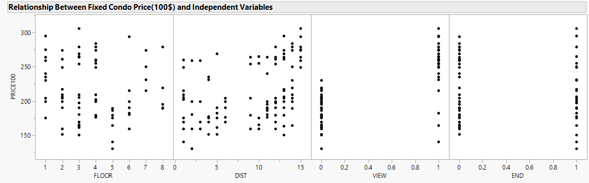

Figure 2 Scatterplot representation of the dependent variable fixed condo price (in 100$) against the independent variables floor level, distance of unit from elevator, ocean view presence, end unit or not.

From figure 2 one could observe that the condo price generally appears to decrease with floor level, increase with distance from elevator, increase by the presence of ocean view and no significant change if the condo is an end unit or not.

|  |  |
| --- | --- |
| Statistic | Condo Price (in 100$) |
| Mean | 211.04 |
| Standard Deviation | 42.73 |
| Median | 199.00 |
| Min | 130.00 |
| Max | 306.00 |

Table 2 Summary statistics of the dependent variable price of condo

Table 2 shows the summary statistics of the data set. The mean condo price is $21104.00 with a standard deviation of $4273.00. The median condo price was $19900. The minimum condo price was $13000.00, and the maximum was $30600.00.

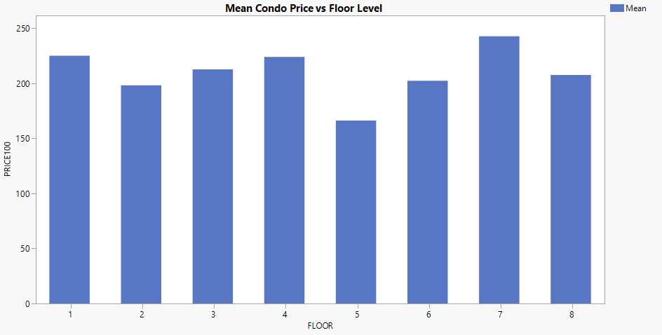

Figure 3 Bar chart of the mean price of condos at each floor

From figure 3 one could observe that the mean condo price changes by floor level. The general trend appears to be that the condo price decreases as the floor level increases except for floor 7. Floor 7 has the highest mean condo price.

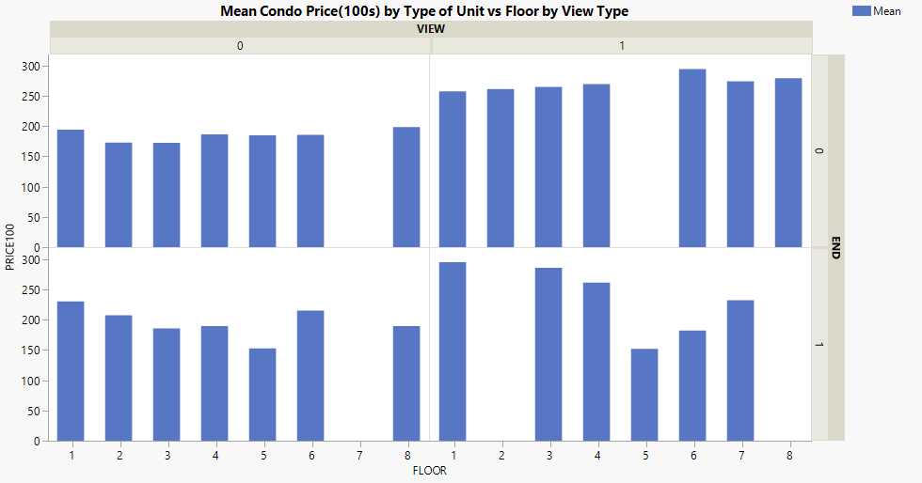

Figure 4 Bar chart of the mean price of condos at each floor with or without an ocean view for end units and non-end units

Figure 4 shows that the mean price of condo units changes by type of unit and by view. For non-end units without an ocean view there does appear to be slight decrease in price as floor level increases. Non-end units with ocean view are generally more expensive than end units without an ocean view. There does appear to be a slight increase in price for the higher floor levels of these units. For end units without an ocean view, the general trend appears to be that the price decreases as the floor level increases. In general, end units with an ocean view increase and then decrease in price as the floor level increases.

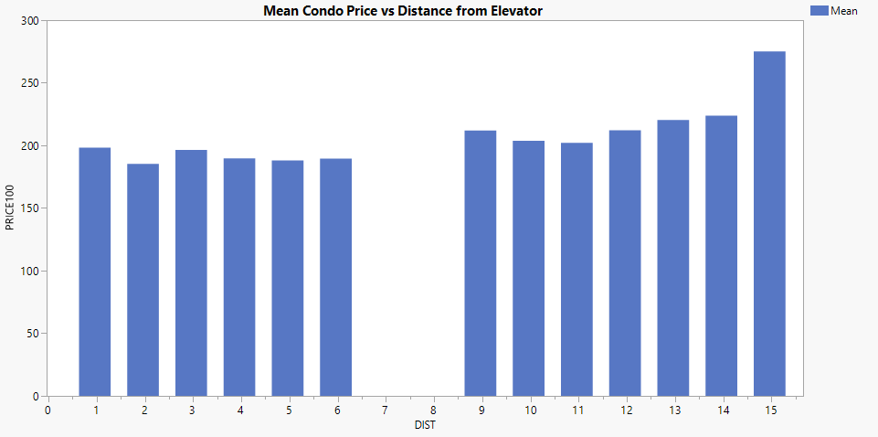

Figure 5 Bar chart of the mean price of condos vs distance from elevator measured in amount of condo units

Figure 5 shows that in general, the mean price of condo increases with the distance from the elevator.

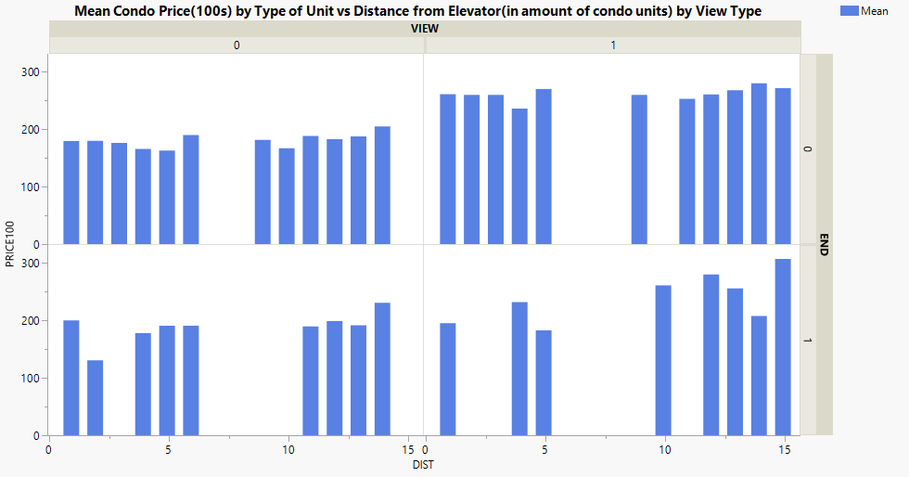

Figure 6 Bar charts comparing mean condo unit price(100s) for end units, non-end units and ocean view, no ocean view against distance from elevator measured in the amount of condo units a unit is away from the elevator of the complex.

Figure 6 shows that in general, the unit price increases with increase in elevator distance across both types of units with and without ocean views. The increase appears to be more dramatic for end units with an ocean view.

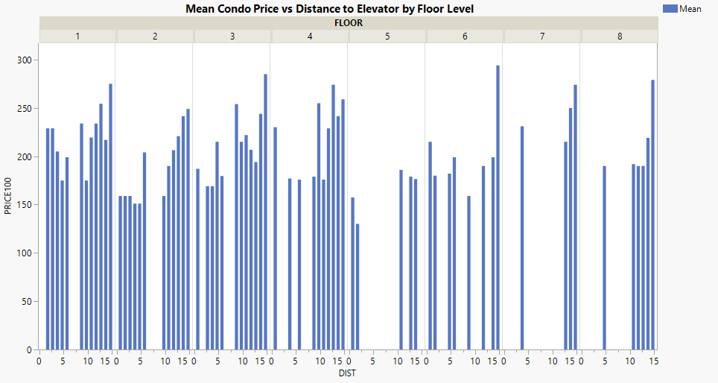

Figure 7 Bar charts of mean price of condo unit vs distance from elevator by floor level. The distance of units is measured in amount of condo units the unit is from the elevator.

Figure 7 shows the effect from figure 6 on each floor level. That is, that the mean condo price increases with elevator distance on each floor level.

|  |  |  |  |  |
| --- | --- | --- | --- | --- |
| Model | R2adj | S(100s) | MSE(100s) | F global |
| 1 | 0.68 | 24.07 | 579.5 | 55.5 |
| 2 | 0.73 | 22.18 | 492.1 | 31.72 |
| 3 | 0.76 | 20.96 | 439.43 | 21.11 |
| 4 | 0.77 | 20.58 | 423.72 | 18.76 |

Table 3 Model results coefficient of determination adjusted, standard deviation, mean square error and global F statistic

|  |  |  |  |  |  |  |
| --- | --- | --- | --- | --- | --- | --- |
| Test | SSER | SSEC | k-g(  #β tested in H0) | MSEC | F Stat (comparing to model i to i- 1) | Critical Value Fa = 0.01 |
| 1 | 56787.91 | 45766.79 | 5 | 492.1 | 4.48 | 3.22 |
| 2 | 45766.79 | 37791.14 | 7 | 439.43 | 2.59 | 2.85 |
| 3 | 45766.79 | 35168.42 | 10 | 423.72 | 2.5 | 2.54 |

Table 4 Model Comparisons showing the necessary variables to calculate the F statistic for the nested models when comparing model i to model i-1 at significance level of α = 0.01

Test 1 model 1 vs model 2

A hypothesis test was performed to determine whether the added interactions parameters in model 2 are significant to the prediction of the condo fixed price. That is are at least one of the additional parameters in model 2 not equal to 0. H0:  β5 = β6 = β7 =β8 = β9 = 0 vs Ha: At least one of the coefficients is not 0. Because the F statistic > Fa = 0.01, namely 2.61 > 2.26, therefore we reject H0, there is sufficient evidence to support the claim that the addition of interaction terms in model 2 does significantly contribute to the prediction of fixed condo price.

Test 2 model 2 vs model 3

A hypothesis test was performed to determine whether the added quadratic parameters in model 3 are significant to the prediction of the condo fixed price. That is are at least one of the additional parameters in model 3 not equal to 0. H0: β10 = β11 = β12 =β13 = β14 =β15 = β16= 0 vs Ha: At least one of the coefficients is not 0. Because the F statistic < Fa = 0.01, namely 2.59 < 2.85, we fail to reject H0, there is not sufficient evidence to support the claim that the additional quadratic terms in model 3 significantly contribute to the prediction of fixed condo price.

Test 3 model 2 vs model 4

A hypothesis test was performed to determine whether the added quadratic parameters in model 3 are significant to the prediction of the condo fixed price. That is are at least one of the additional parameters in model 4 not equal to 0. H0: β10 = β11 = β12 =β13 = β14 =β15 = β16 = β17 =β18 = β19 = 0 vs Ha: At least one of the coefficients is not 0. Because the F statistic < Fa = 0.01, namely 2.50 < 2.54, we fail to reject H0, there is not sufficient evidence to support the claim that the additional quadratic terms in model 4 significantly contribute to the prediction of fixed condo price.

All four models have a relatively high R2adj. The R2adj, standard deviation and mean square error values appear to improve with each subsequent model. However, partial f-tests on the nested models shows that first order interaction terms in model 2 contribute significantly to the prediction of condo price and that the additional second order terms from model 3 and 4 does not. Therefore, model 2 was selected as the best model for further investigation.

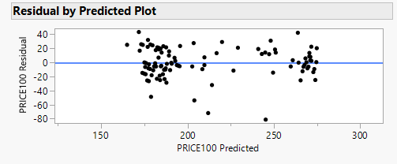



Figure 8 Plot of condo price residuals from model 2 vs predicted price

Figure 9 Distribution of Model 2 Condo Price Residuals

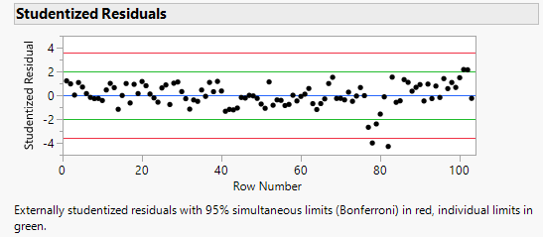

Figure 10 Standardized residual plot of condo price vs row number

Figure 11 Residual distribution of condo price with observation 78 and 82 removed

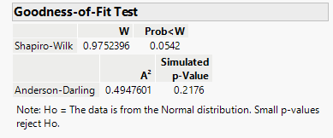

Figure 12 Shapiro-Wilks test on residual distribution of condo price with observation 78 and 82 removed

The residual plot (figure 8) indicates that the variance of the residuals seems to be constant, and no discernible pattern is observed indicating the residuals are independent. There are two observations that are potential outliers between 200-250 on the x-axis (row 78 and 82). Figure 10 shows that these observations can indeed be deemed outliers as they are passed the three standard deviations from mean threshold. However, the observations (78 & 82) have a Cook’s distance of 0.43 and 0.25 respectively. Both Cook’s distances are smaller than the 50th percentile of the f distribution, therefore, these outliers are not significantly influential [2]. Figure 9 shows that the distribution of the condo price residuals is left skewed indicating that the error terms are not normally distributed. Figure 11 & 12 shows that when the two outliers are removed the residual distribution is approximately normal. Therefore, these two observations are responsible for skewing the residual distribution in figure 9. However, seeing as these outliers are a natural part of the data set (both are ocean view end units on the 5th floor) this analysis will carry on without removing them.

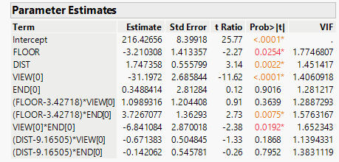

Figure 13 model 2 parameters

Figure 13 shows the model parameters for model 2. No parameters were dropped from the model because whenever a model includes many interactions and/ or squared terms, several t-tests for parameters may be nonsignificant even if the global F test is significant [2]. From the VIF values there does not appear to be any evidence of multicollinearity.

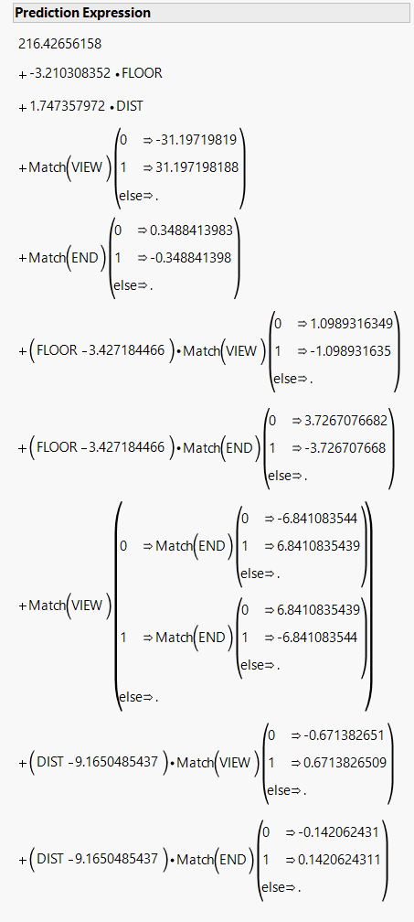

Figure 14 Prediction expression of model 2

|  |  |
| --- | --- |
| End Unit  (vertical) | Ocean View  (horizontal) |
|  | 0 | | 1 |
| 0 | 178.74 – 3.21X1 + 1.75X2 + (X1-3.43) *1.10 + (X1-3.43)*3.73 + (X2-9.17) * -0.67 + (X2-9.17) * -0.14 | | 254.82 – 3.21X1 + 1.75X2 + (X1-3.43) * -1.10 + (X1-3.43) *3.73 + (X2-9.17) * 0.67 + (X2-9.17) *-0.14 |
| 1 | 191.72 - 3.21X1 + 1.75X2 + (X1-3.43) * 1.10 + (X1-3.43) *-3.73 + (X2-9.17) * -0.67 + (X2 – 9.17) * 0.14 | | 240.44 – 3.21X1 + 1.75X2 + (X1-3.43) * -1.10 + (X1-3.43) *-3.73 + (X2-9.17) *0.67 + (X2 – 9.17) *0.14 |

Table 5 Prediction expressions for each type of unit and location of unit. Values were obtained from the general prediction expression in figure 14. Note X1 ranges from 1-8 and X2 ranges from 1-15

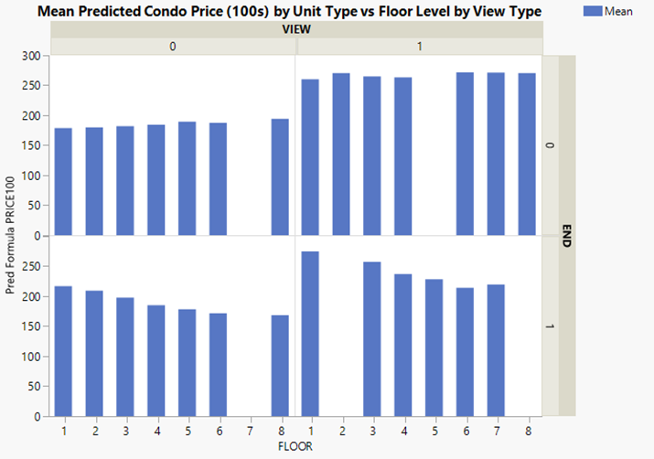

Figure 15 Bar graphs of model 2’s mean predicted condo price by unit type vs floor level by view type

Figure 16 Bar graphs of model 2’s mean predicted condo price by unit type vs distance by view type

The prediction expressions in table 5 were used to calculate the predicted values in figures 15 & 16. Figures 15 & 16 show the predicted values for condo price for the two types of unit and views using model 2. As observed in table 5, Figure 15 & 16, In general the price of every unit is influenced by the floor level and the distance from the elevator (X1 and X2) and the type of unit and view (X3 and X4). For a non-end unit without an ocean view, the price of the unit slightly increases as floor level and distance increases. For an end unit without an ocean view, the price of the unit decreases as the floor level increases, and the unit price increases as the distance from the elevator increases. For a non-end unit with an ocean view, the unit price decreases as the floor level increases and generally increases as the elevator distance increases. For an end unit with ocean view, the price of the unit decreases as the floor level increases and increases as the distance from the elevator increases.

According to the prediction expressions in table 5, the cheapest type of unit is an end-unit without an ocean view on the 8th floor that’s 1 unit away from the elevator (X1 = 8, X2 = 1). The most expensive type of unit is an end unit with an ocean view that’s on the 1st floor and 15 units away from the elevator (X1= 1, X2 =15). A non-end unit with an ocean view on the 1st floor and 15 units away from the elevator is a close second. Ocean view units are more expensive than units without, further, this difference in price is more stark between non-end units. End units without an ocean view are more expensive than non-end units without an ocean view on the lower floors, but end units become less expensive than non-end units on the higher floors.

**Conclusion**

This analysis investigated how a seller’s fixed condominium price is affected by the independent variables floor level, distance from the elevator, presence or absence of an ocean view, and unit type (end-unit and non-end units). Summary statistics and bar charts were used in the preliminary stages of the analysis to better understand the data. Four models with added sequential complexity were proposed and compared. Through partial F-tests between the models, model 2 was selected to be the best and used for further analysis. The unit’s fixed sale price appears to be affected by all four independent variables. For a non-end unit without an ocean view the price appears to slightly increase with the increase of floor level and increase with distance from elevator. For all other types of units, the general trend appear to be that the unit price decreases with the increase of floor level, and increase with the increase of distance from the elevator. Units with an ocean view tend to be more expensive than the same type of units without an ocean view and is a difference more dramatic between non-end units. End units without an ocean view tend to be more expensive than non-end units without an ocean view on the lower floor, but not on the higher floors. In conclusion the seller’s fixed price depends on where the unit lies in the complex and what the views are.

**References**

1. Gordon, B., Winkler, D., Barrett, D., & Zumpano, L. (2013). The effect of elevation and corner location on oceanfront condominium value. *Journal of Real Estate Research*, *35*(3), 345–364. doi:10.1080/10835547.2013.12091370
2. Mendenhall, W. and Sincich, T. (2020) *A second course in statistics regression analyisis*. 8th edn. Hoboken, NJ: Pearson Education, Inc.